SIMATS ENGINEERING (SAVEETHA SCHOOL OF ENGINEERING)
Department of Computer Science and Engineering

ASSESSMENT TOOL 2 – Traversal Challenge

Course Code: | CSA0305 | Course Title: |  | Data Structures
CO Assessed: | CO3 – Precision (BL3, BL5) | Assessment: |  | Assessment Tool 2 – Traversal Challenge
Weightage: | 30% of CIA | Total Marks: |  | 100
CO3 Statement: | Solve problems for optimized data storage and retrieval using Binary Search Trees, AVL Trees, BTrees, Red-Black Trees, and Splay Trees.
Student Name: | M.Deepika |  | Reg. No.: | 192372296
Section / Batch: | 2023 |  | Date: | 03/08/2026

Code of Conduct
I ______M.Deepika-192372296___________ (Name / Reg No) certify that this submission is my original work and that I have adhered to the guidelines specified for this assessment. I understand that any violation of academic integrity rules will result in disciplinary action. Signature of the Student: ____deepika.m___

Instructions
- This assessment tool contains 5 Traversal Challenge questions, Total: 100 Marks.
- Students can use any online/offline Traversal Challenge. Demonstrate tree.
- When a student answer using simulator, in evaluation the answer should have captured screenshots after every major operation
- Submit the report in PDF format with properly labelled screenshots as proof of completion.

Section / Topic | Focus | Q Nos Marks
Tree Traversals | Traversal types, In order, Post order and Pre order | 5 | 100
 | GRAND TOTAL: | 100 Marks

Traversal Challenge

Rubrics for Calculation

Criteria | Weightage | Level 4 – Exemplary | Level 3 –  Proficient | Level 2 –  Developing | Level 1 –  Beginning
Conceptual  Understanding | 20 | Demonstrates thorough understanding of all core Data Structures concepts; answers accurately reflect deep knowledge | Shows good understanding with minor conceptual gaps | Basic understanding; several misconceptions present | Limited understanding; major concepts misunderstood
Traversal Accuracy | 20 | Correctly completes all tree traversals (Preorder, Inorder, Postorder, Level Order) without errors. | Completes most traversals correctly with one minor error. | Correctly performs only some traversals with multiple errors. | Unable to perform most traversals correctly.
Selection of  Appropriate  Traversal | 30 | Correctly selects the appropriate traversal for every given problem scenario. | Selects the correct traversal for most scenarios. | Selects appropriate traversal for only a few scenarios. | Frequently selects incorrect traversal methods.
Completion & Time Efficiency | 20 | Completes all challenges within the allotted time while maintaining accuracy. | Completes most challenges within the time limit. | Completes only part of the challenge or exceeds the time limit slightly. | Unable to complete the challenge within the allotted time.
Evidence Submission | 10 | Uploads complete screenshots showing successful completion, score, and student details. | Uploads screenshots with minor missing information. | Uploads incomplete  or unclear screenshots. | No valid evidence submitted.

Faculty In-charge | Course Coordinator | Program Director
Signature: _______________ | Signature: _______________ | Signature: _______________
Date: ___________________ | Date: ___________________ | Date: ___________________

Question No:1 Write the traversal sequences for following trees

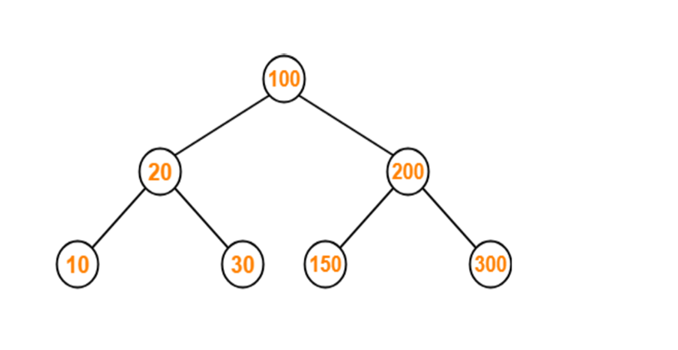
a.preorder

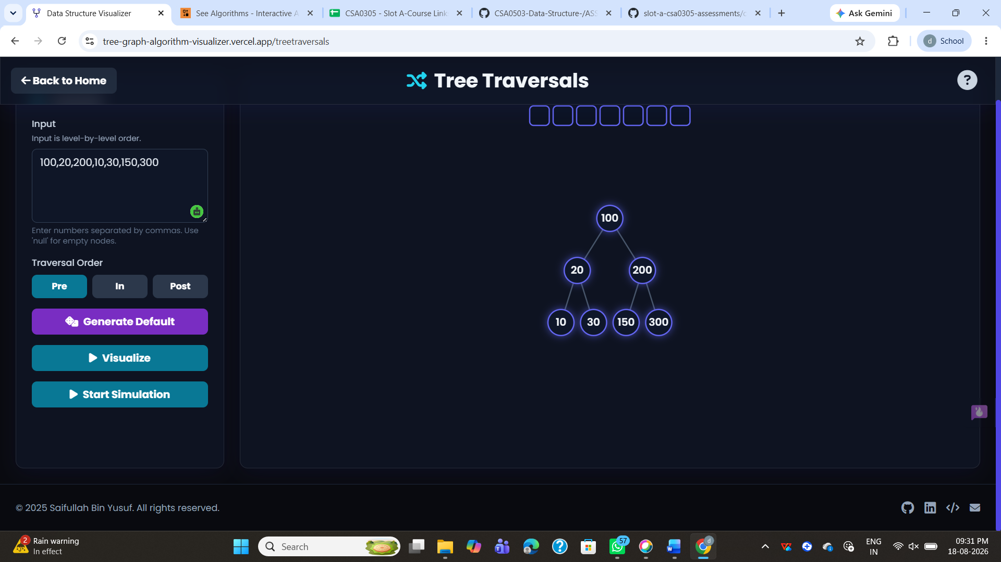

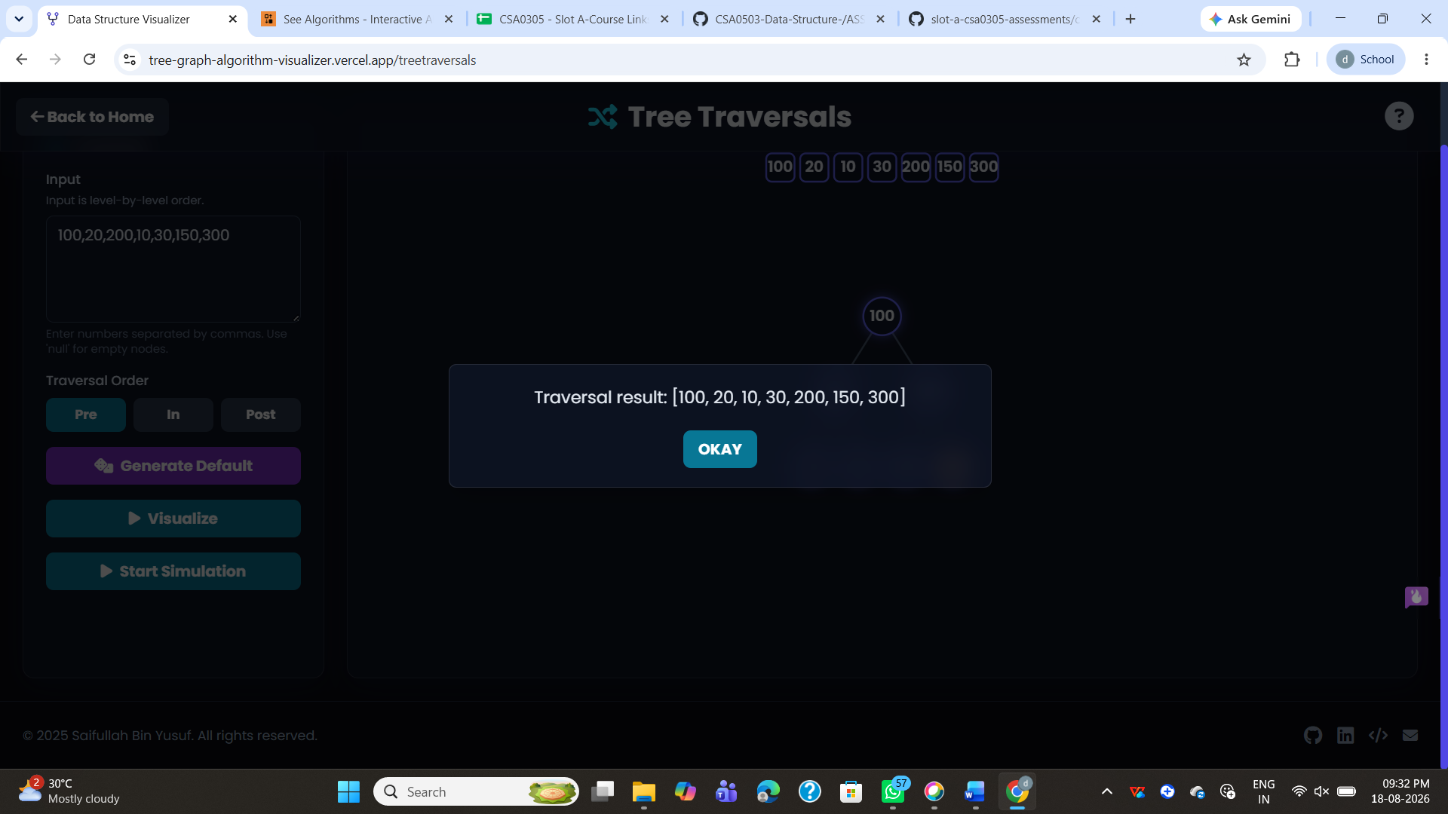

b.Inorder

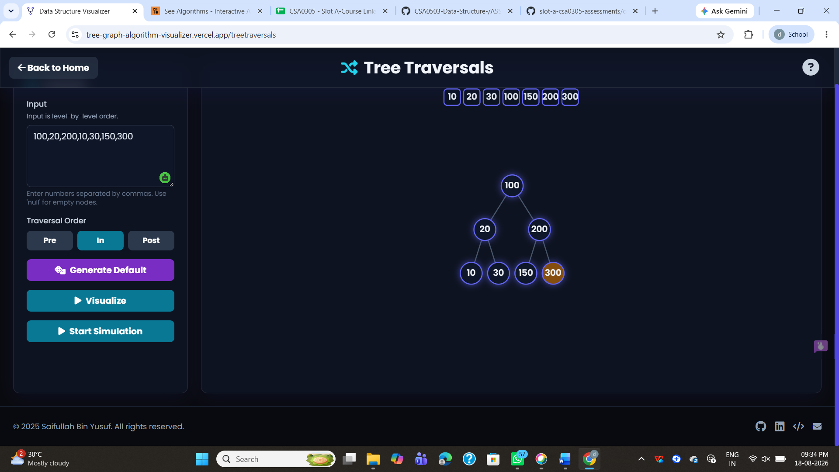

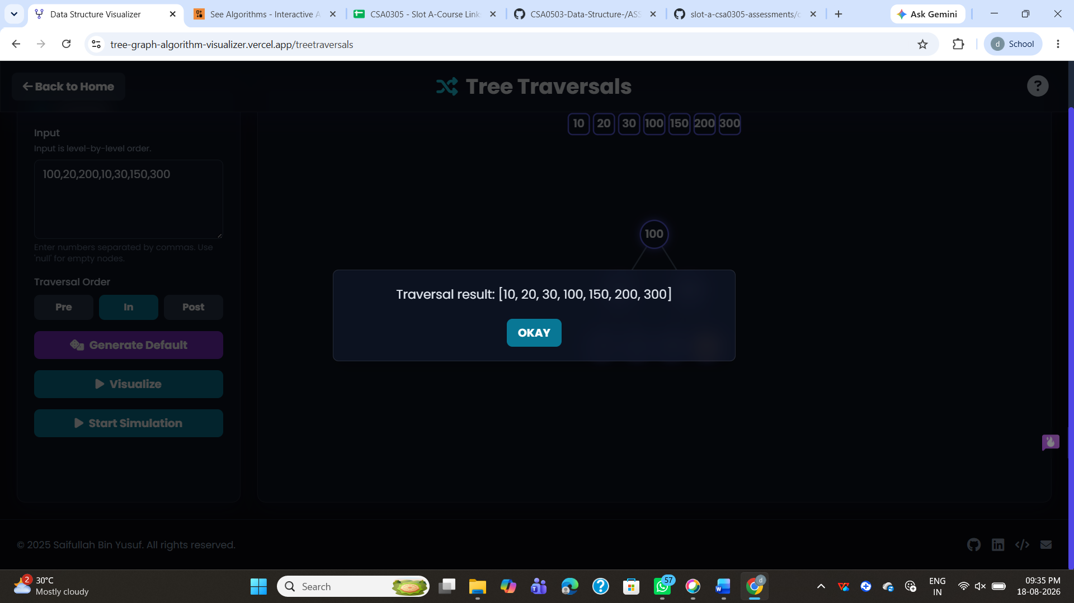

c.postorder

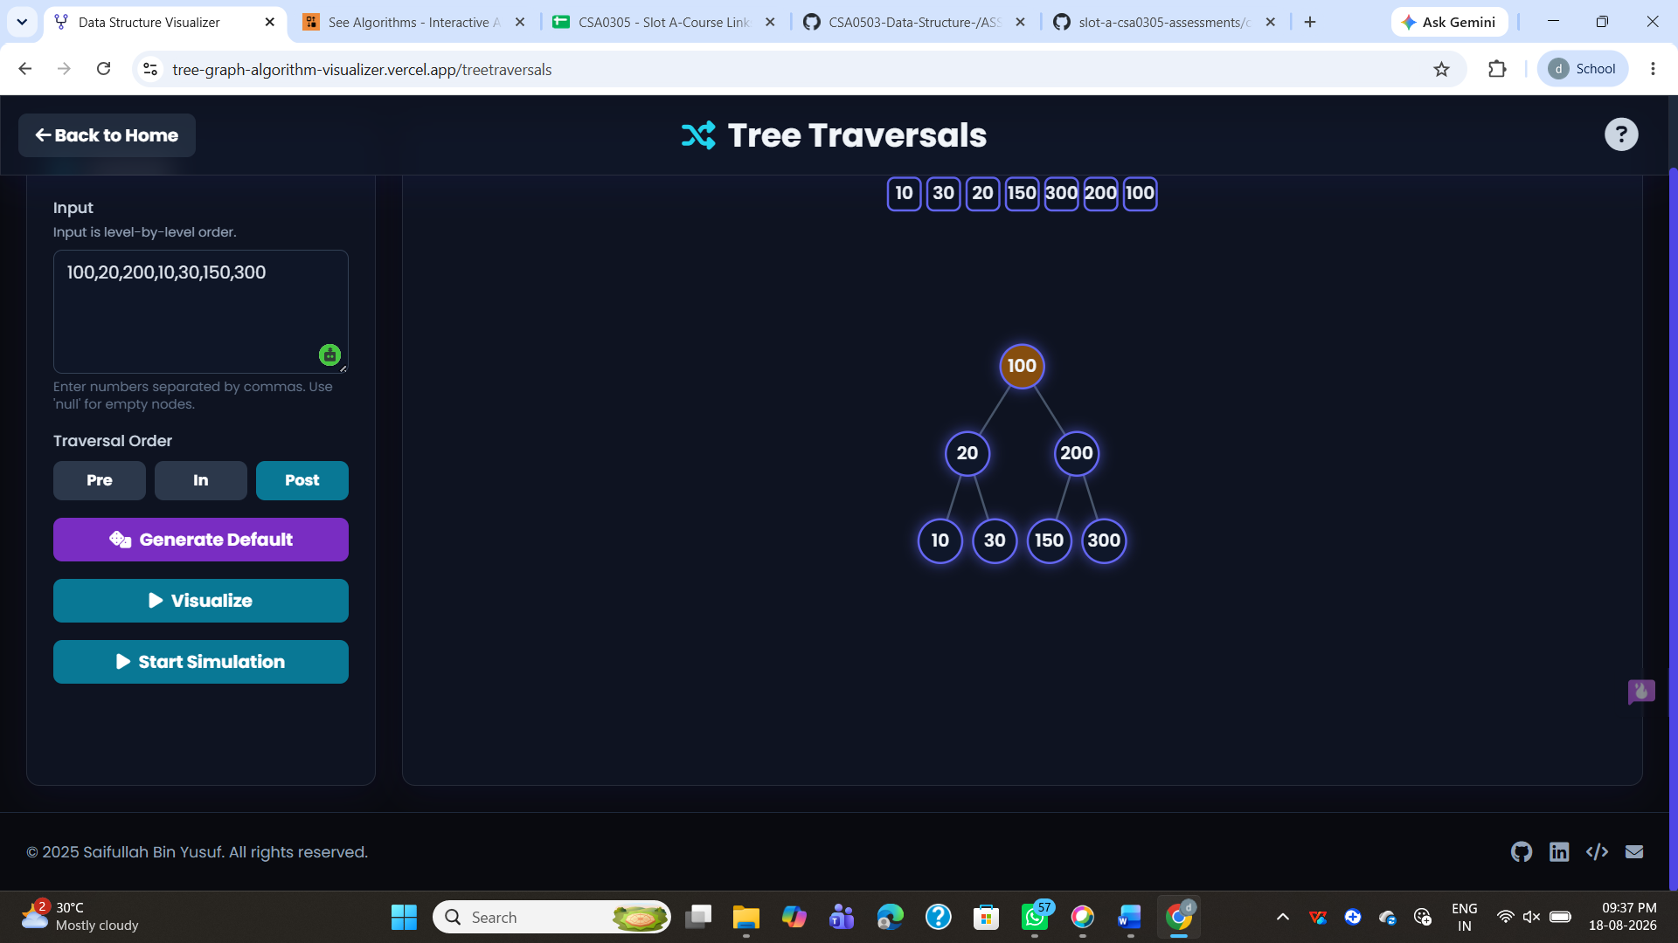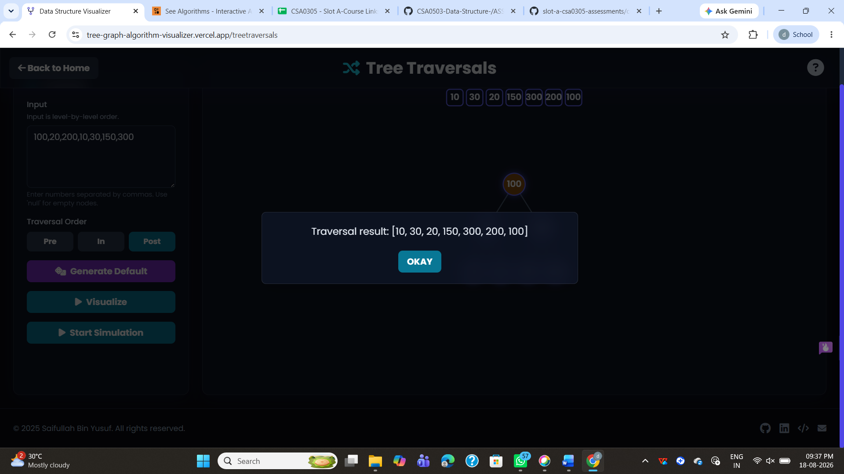

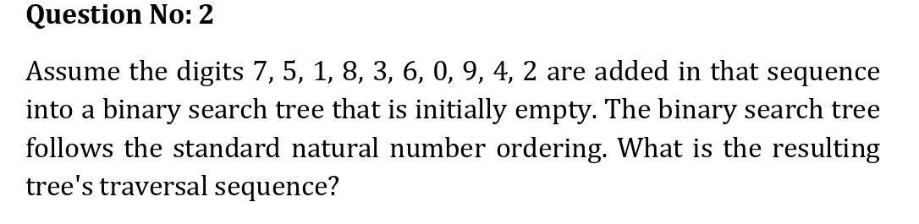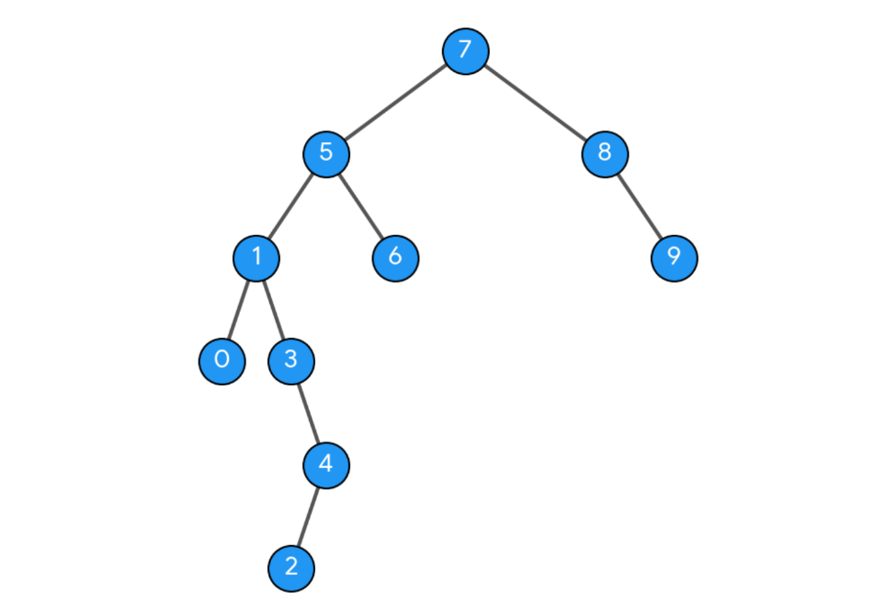

- preorder

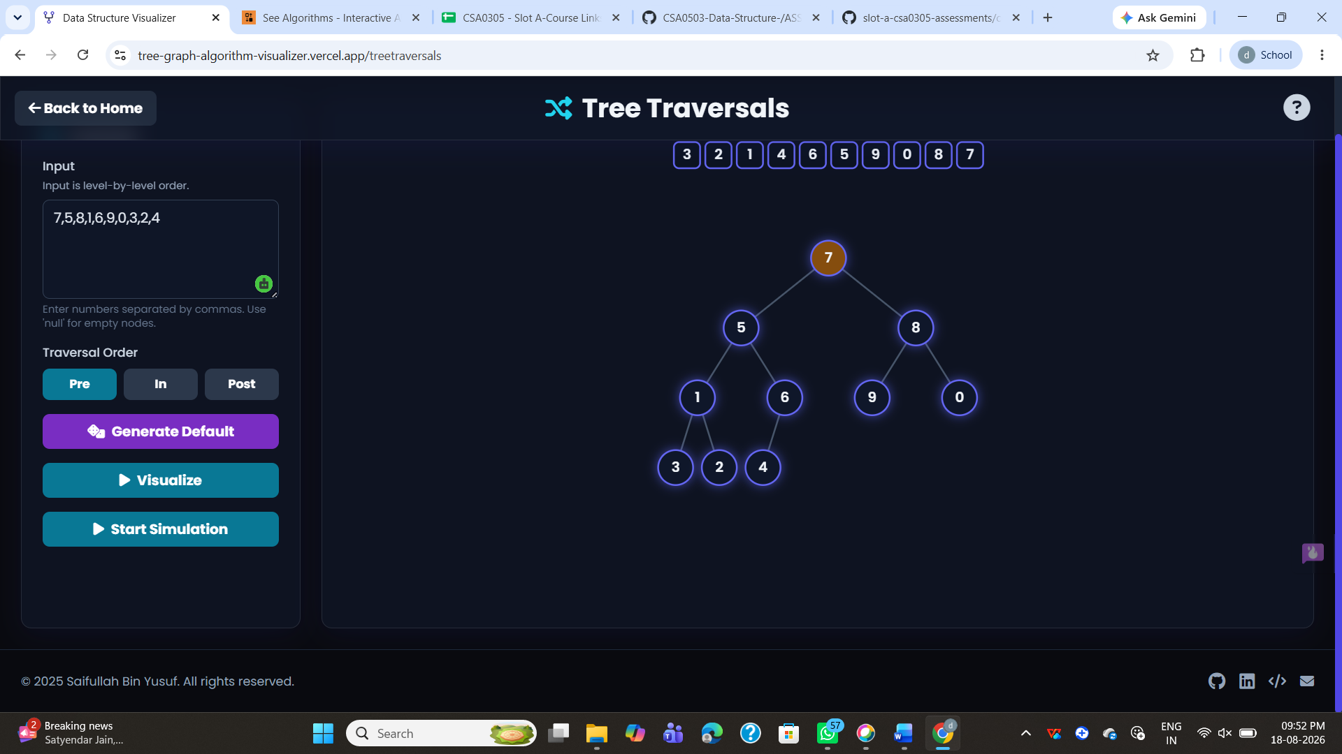
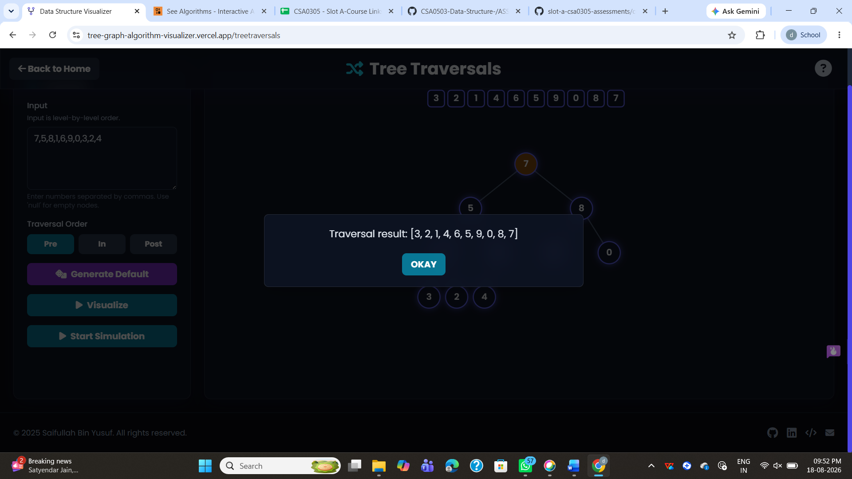

b.Inorder
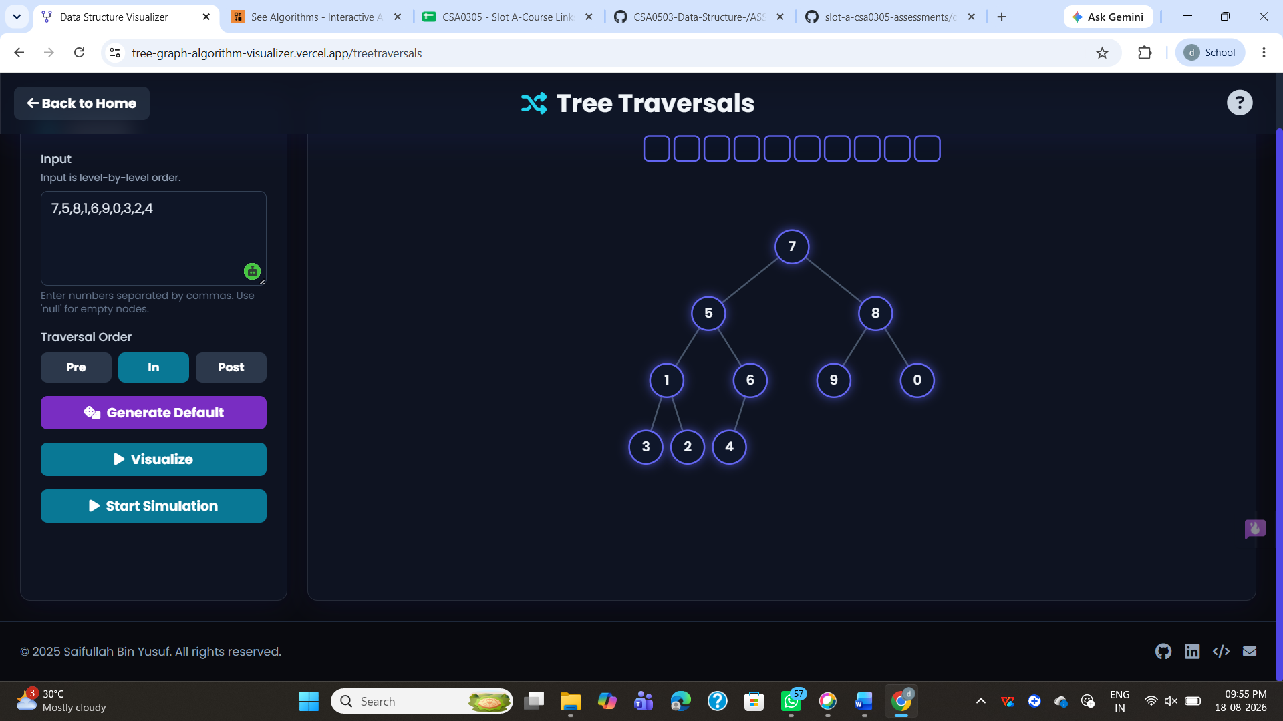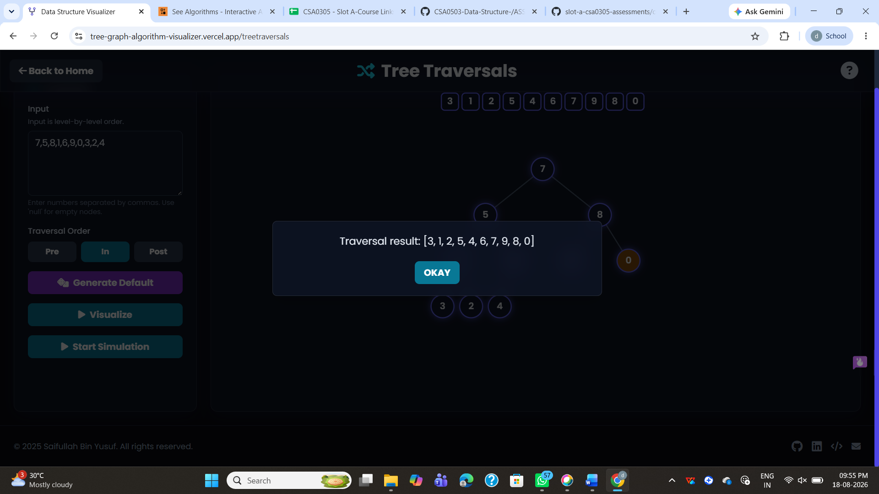

C.Postorder

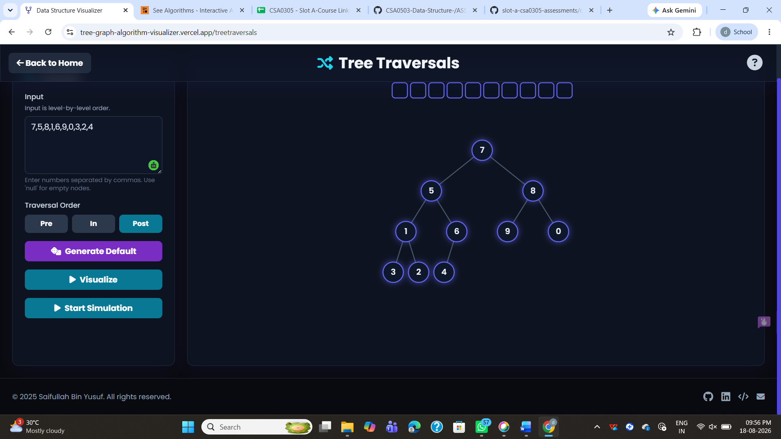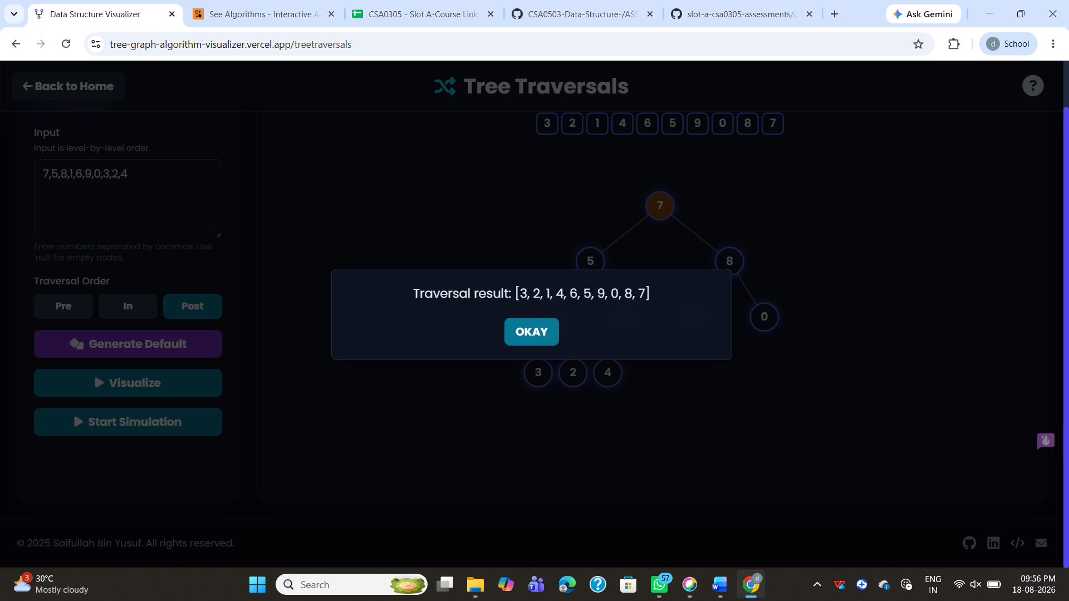

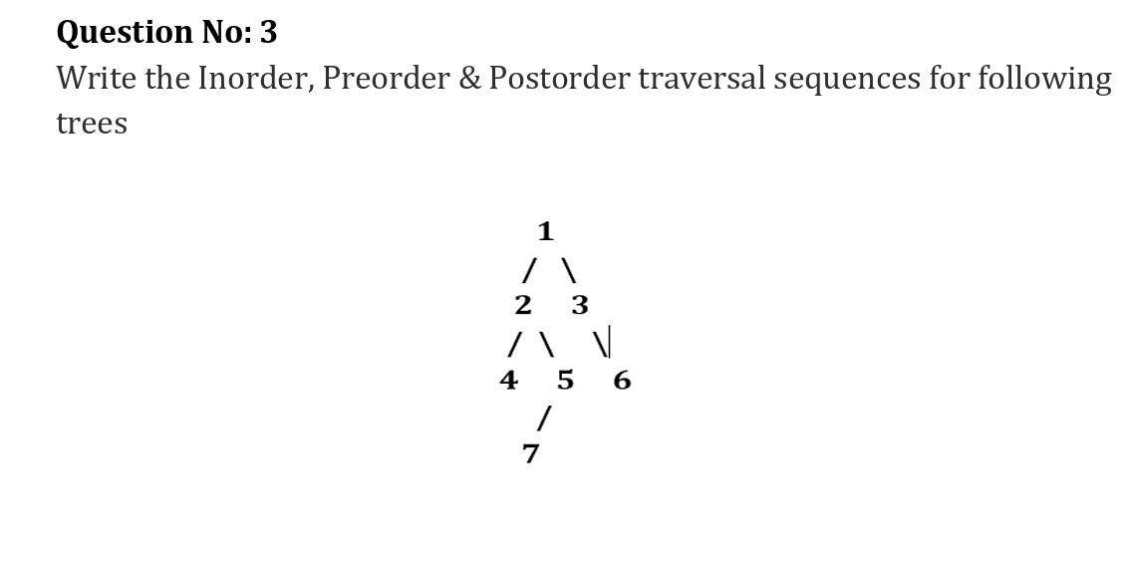

a.preorder

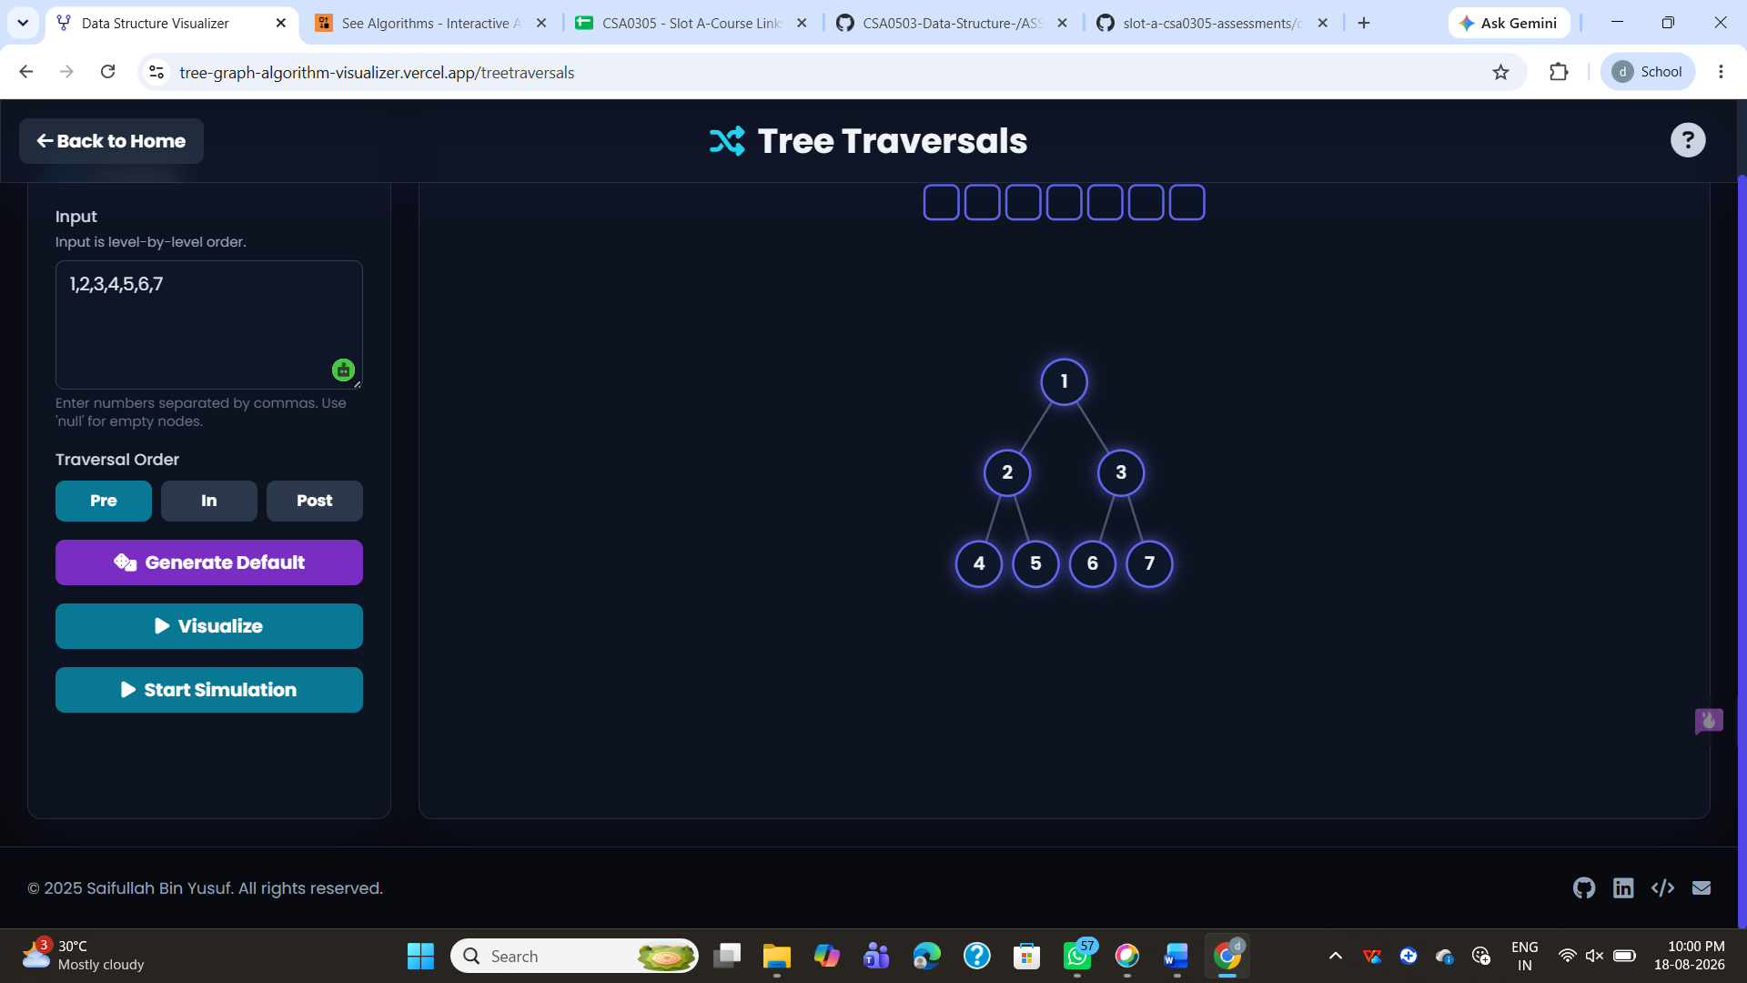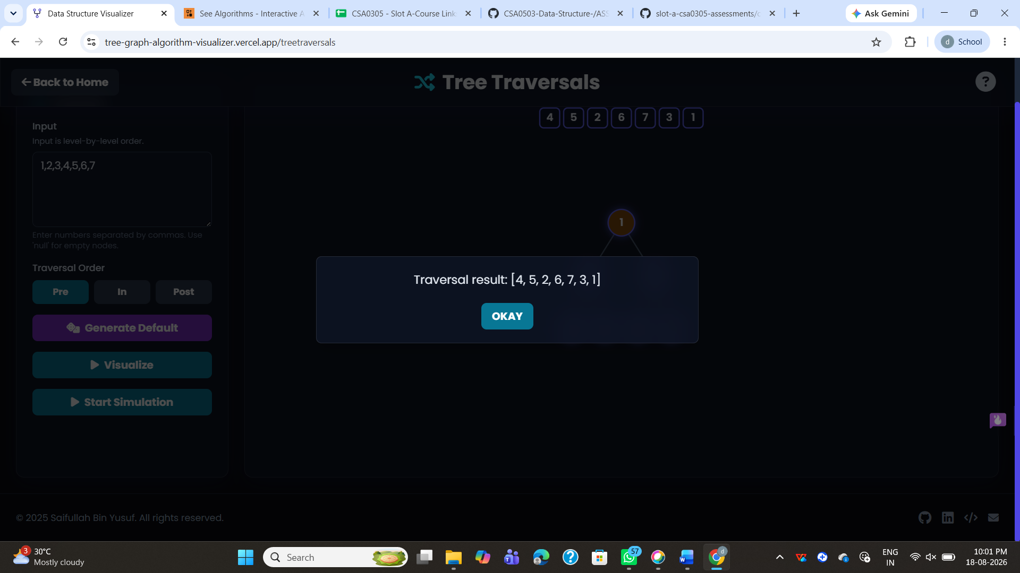

b.Inorder
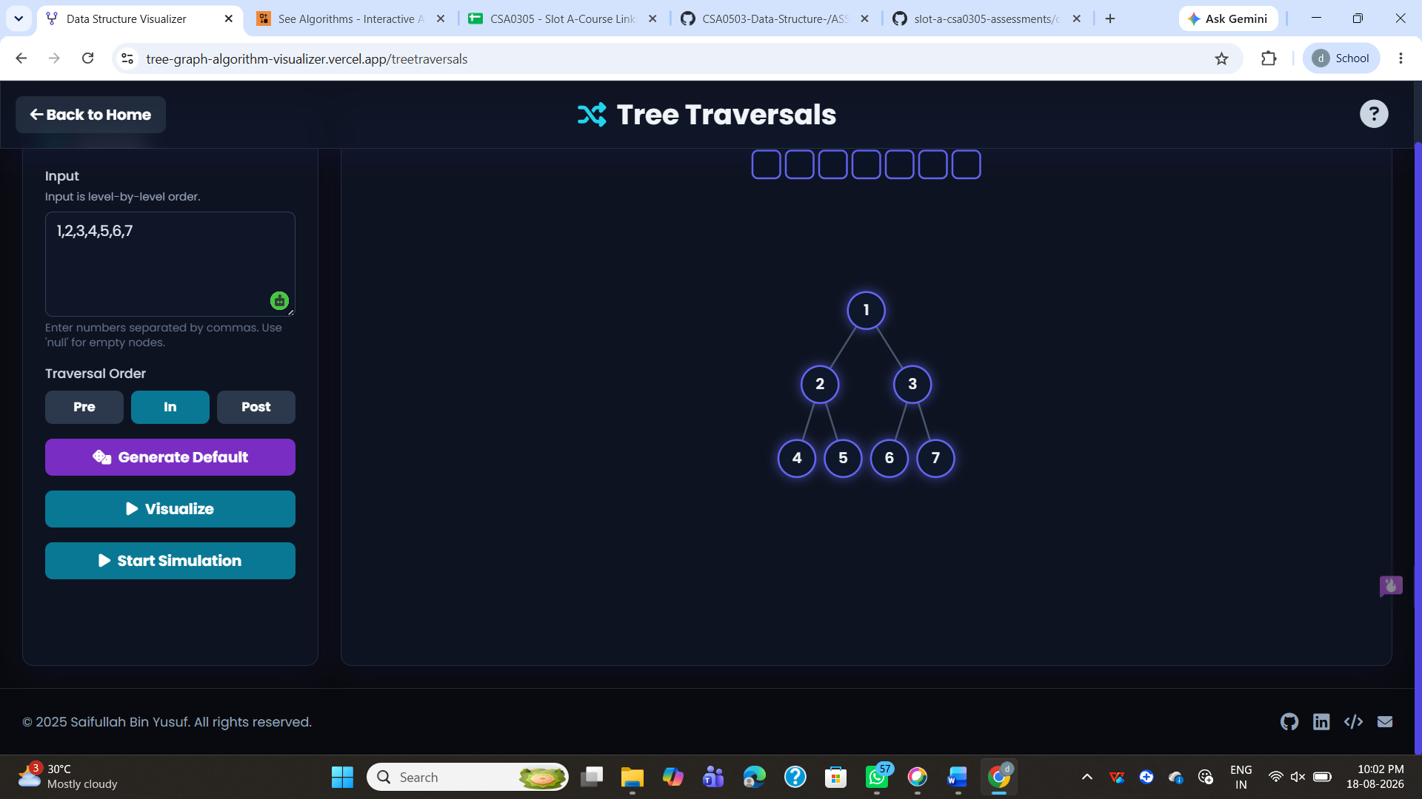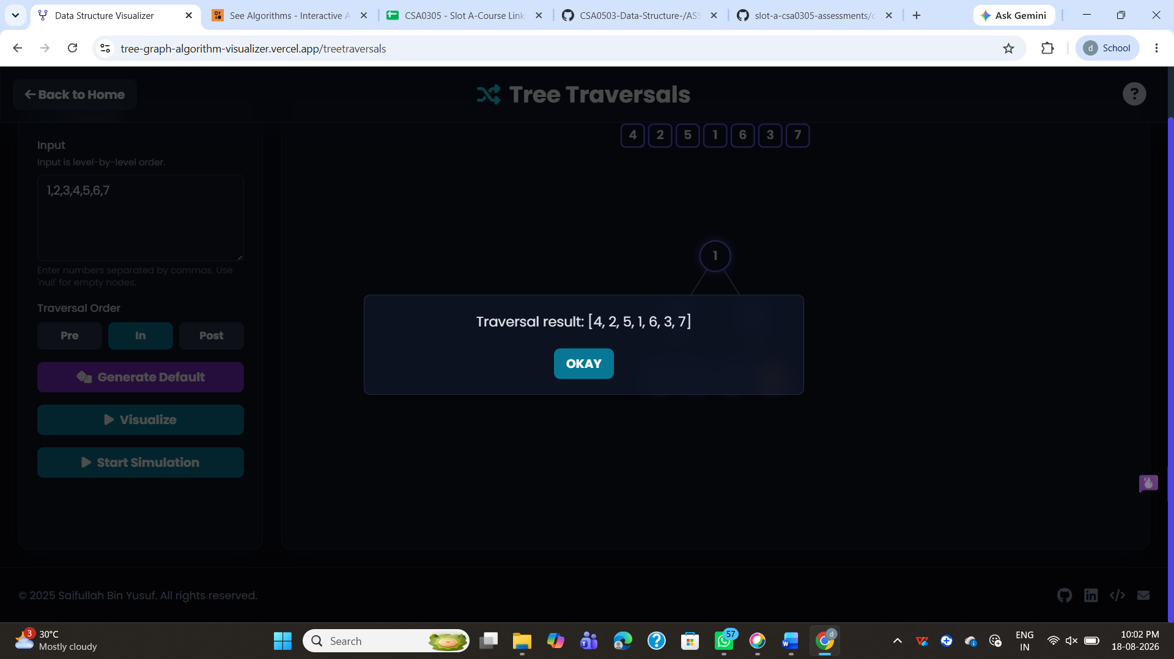

C.Postorder

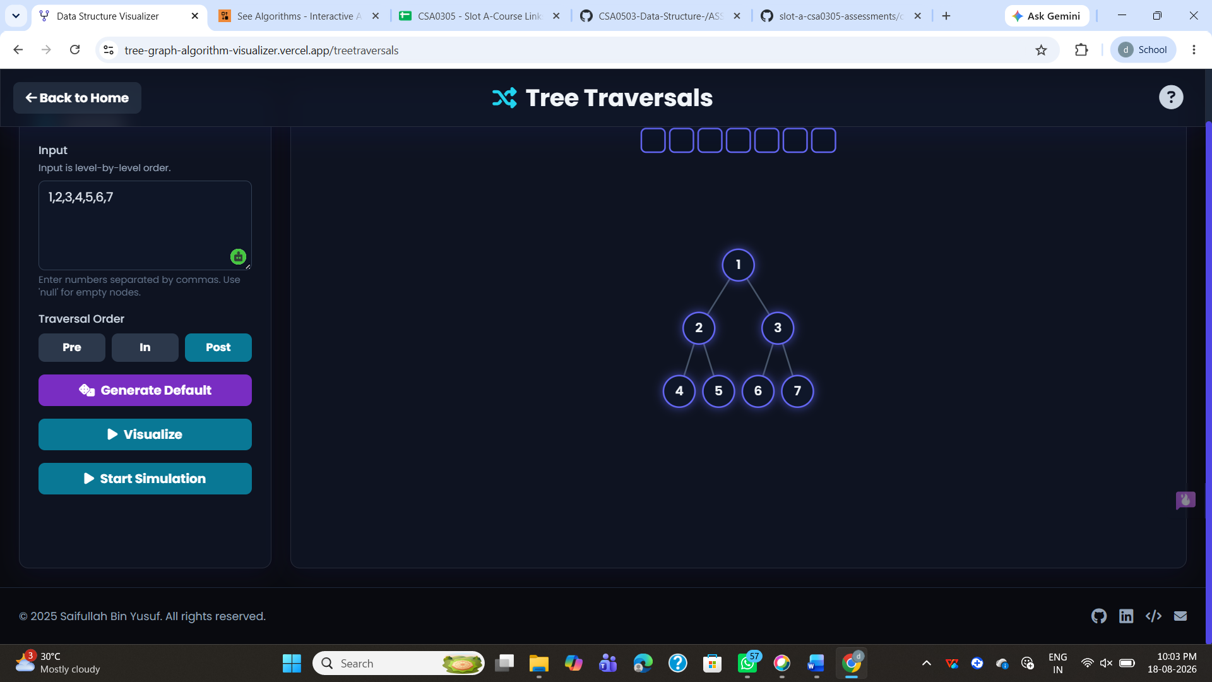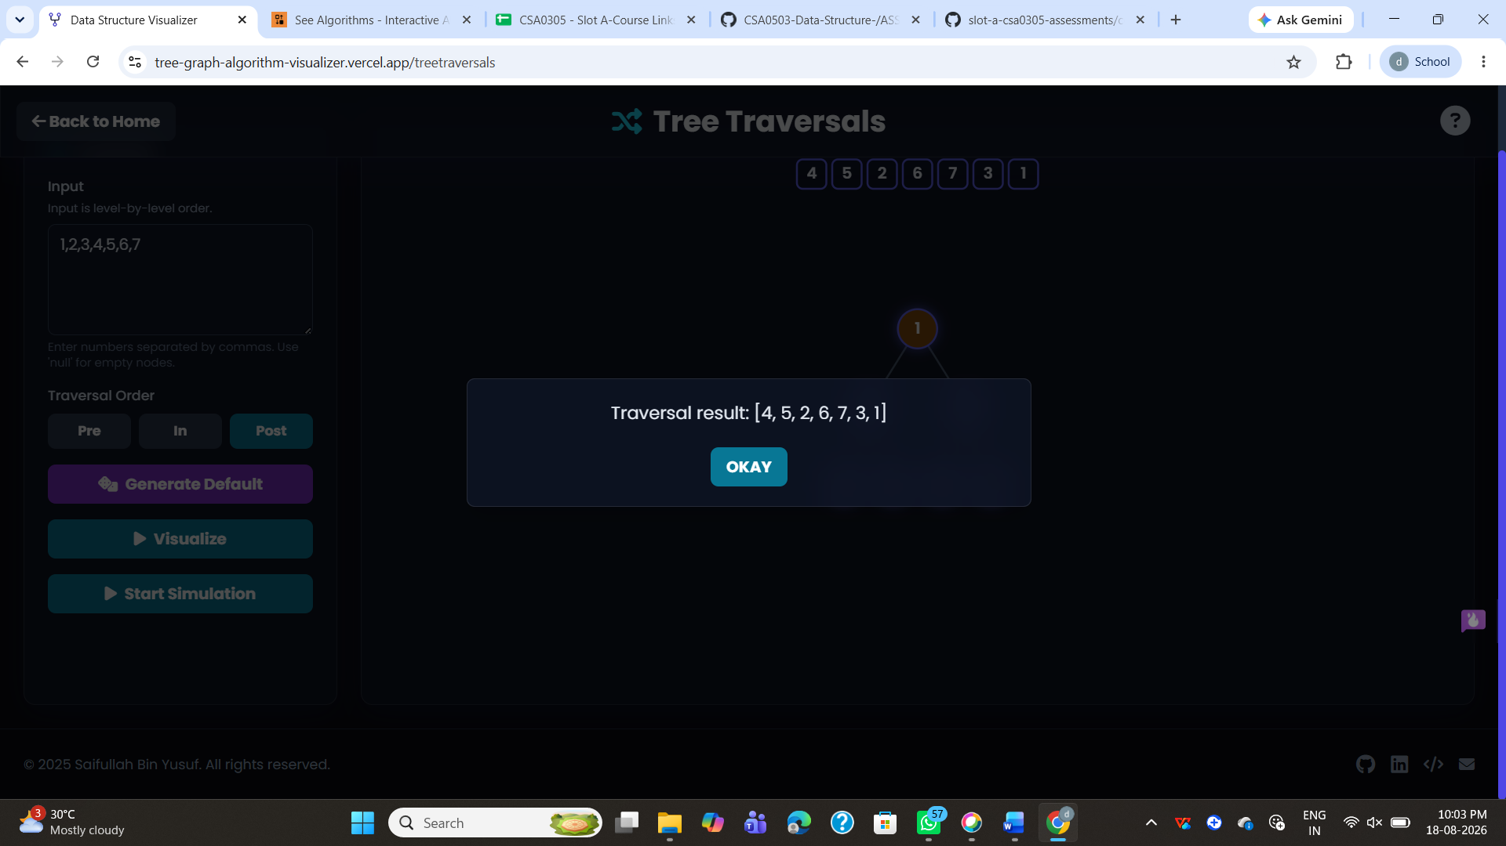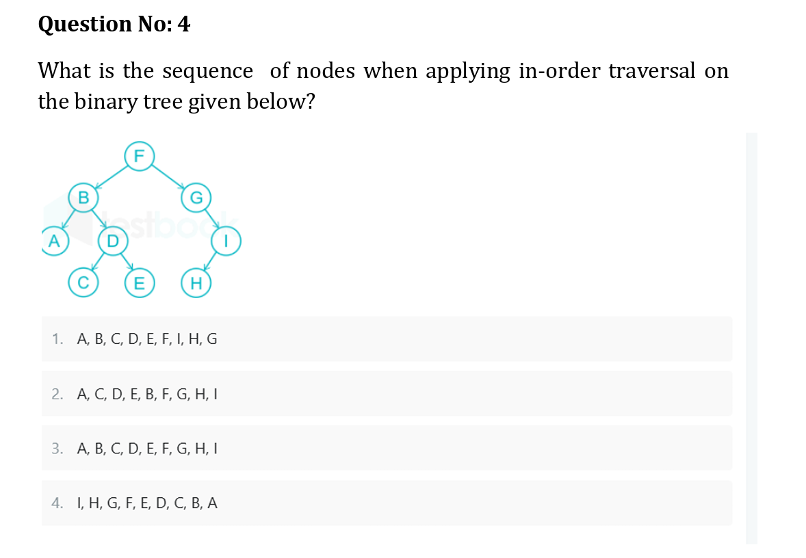
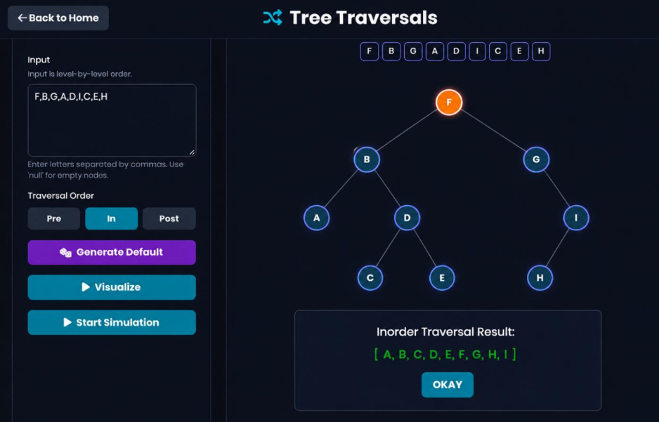

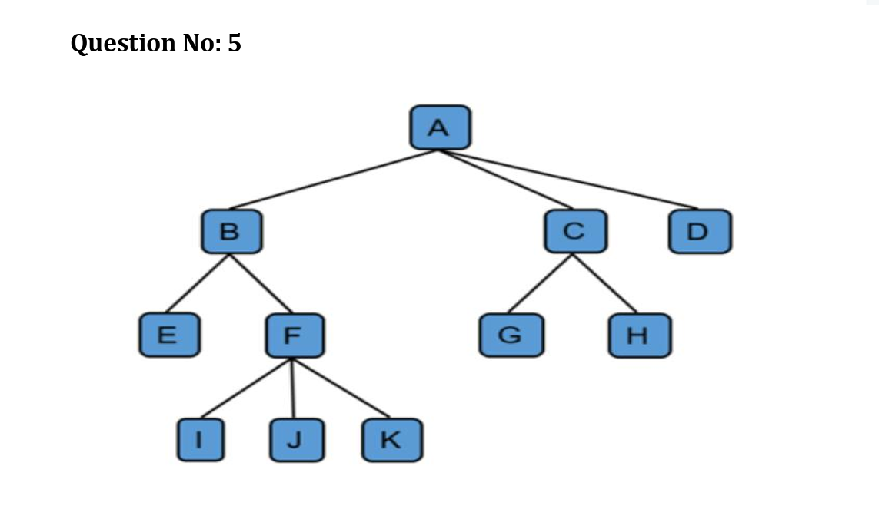
a.Preorder

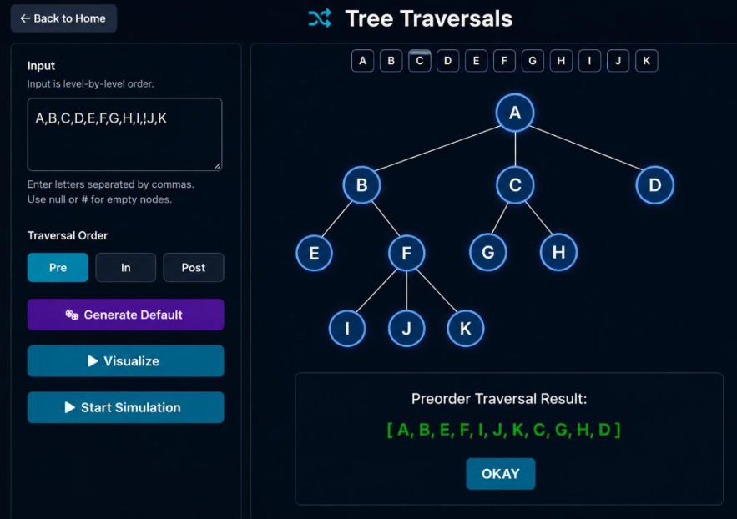

b.Inorder
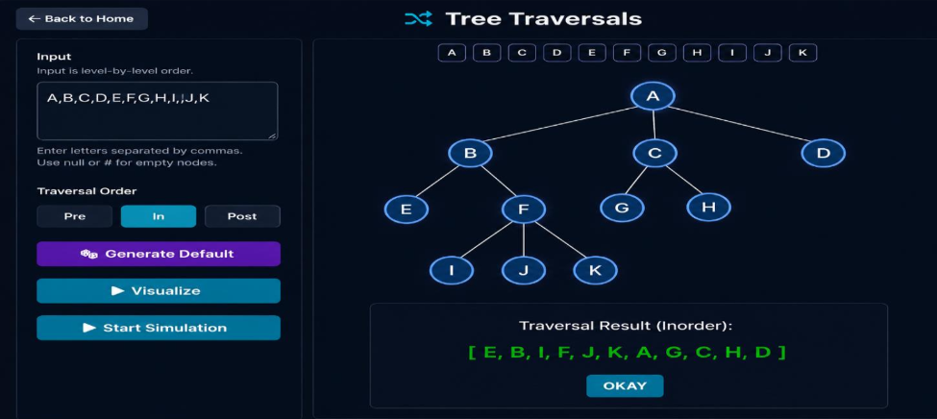
C.Postorder
